**FARM SCAPES:**

A project By:

1. 2210030091 - Vedardha Gudapati (Team Lead).
2. 2210030004 - Dinakar Pathakota (Team Member 1).
3. 2210030064 - Ch Naga Teja (Team Member 2).
4. 2210030024 - A. Sriram (Team Member 3).
5. 2210030078 - N. Varun (Team Member 4).

**Abstract:**

Our project FarmScapes focuses on automating farming completely which reduces the effort of farming that will help in increasing the number of farmers that will come up to farm as it will become a simple process by doing the following:

1. Automatic watering of plants.
2. Giving alerts to the farmer in case of heavy rains.
3. Automatic detection of weed and any plant diseases in the farm with the help of a smart rover that goes through the whole farm every day.

**Overview of working:**

We have used a raspberry pi for processing the images captured by the camera in the rover and comparing them to the 7 layers of the HDF5 file that we got by processing a large dataset of the different types of weed and plant diseases. Moisture sensors placed in the farm control the relay to turn on and off the water supply to the farm by performing according to the JSON codes written and also show live real-time information to the famer and also send data alerts in the case of heavy rains, etc.

**Software & Programming Languages Used:**

1. Node-red
2. JSON(Java Script Object Notation)
3. DATA SET from Kaggle
4. Tensorflow, OS, numpy, OpenCV, Keras
5. Python
6. HDF5 to run the dataset on raspberry pi
7. HTML/CSS.

**Data set:**<https://www.kaggle.com/datasets/vipoooool/new-plant-diseases-dataset>

<https://www.kaggle.com/datasets/vinayakshanawad/weedcrop-image-dataset>

**Accuracy:**

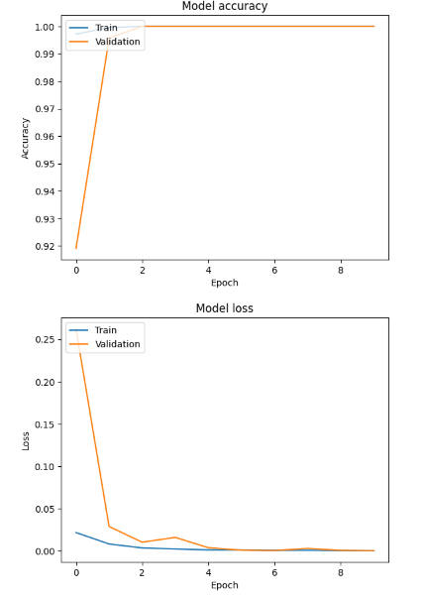

**Real-time Implementation:**

(The picture was shot in college premises)

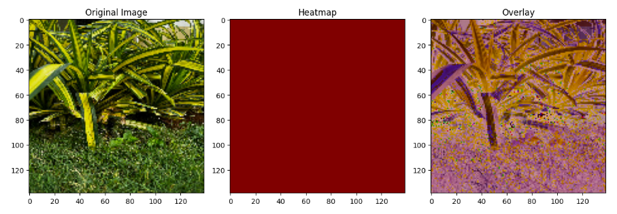

Real-Time dashboard for farmer’s convenience:  
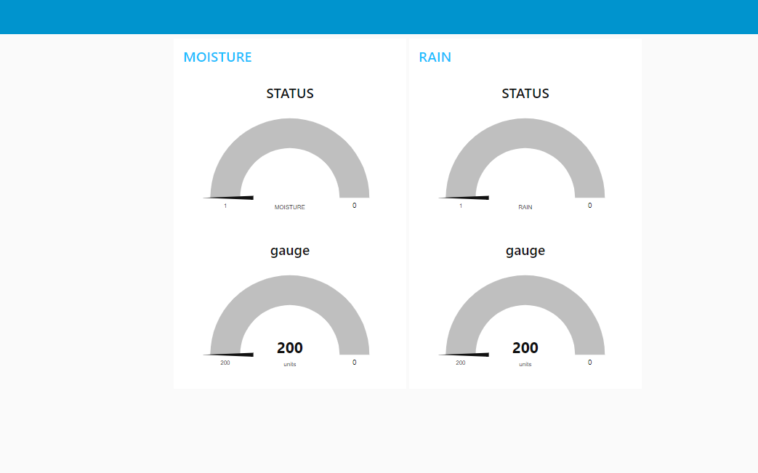

The weed and diseases are detected by comparing the images with a Heatmap. The weed and diseases produce more heat compared to normal plants via which we detect them and send the details and images of the location in the farm to the farmer by taking panoramic shots using a servo motor connected to a camera present in the rover. A showstopper at this place is the processing time taken by the raspberry pi after the data is recorded.

**Hardware components used for monitoring of rain for alerts and moisture levels for automatic watering system and weed and disease detection rover:**

1. **Raspberry pi:**

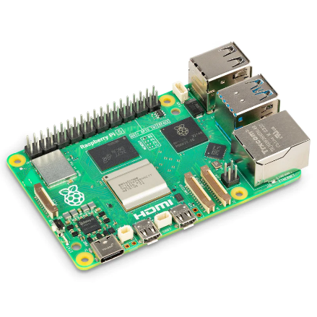

1. **Soil Moisture Sensor (SEN-13322):**

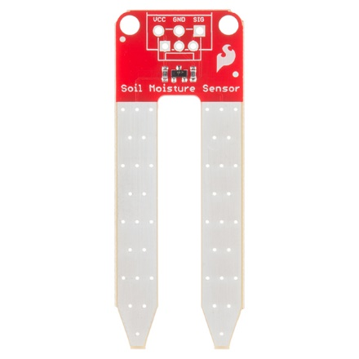

1. **Relay Module:**

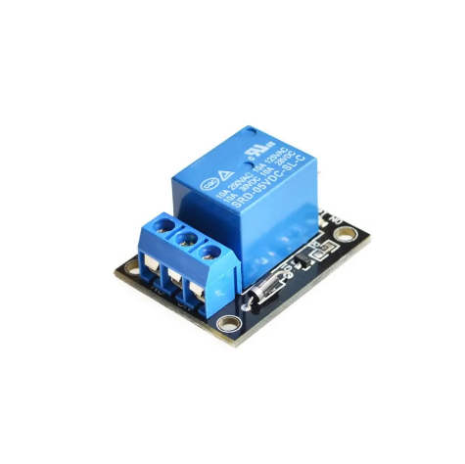

1. **Rain Sensor:**

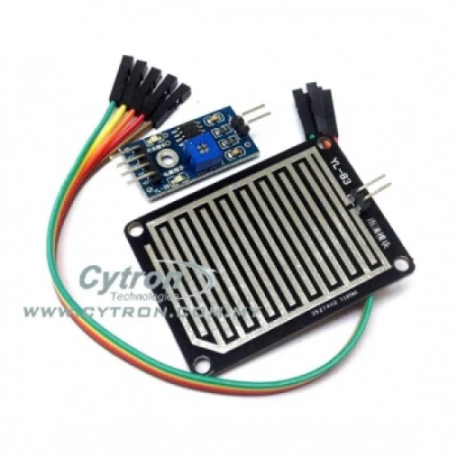

1. **Servo Motor:**

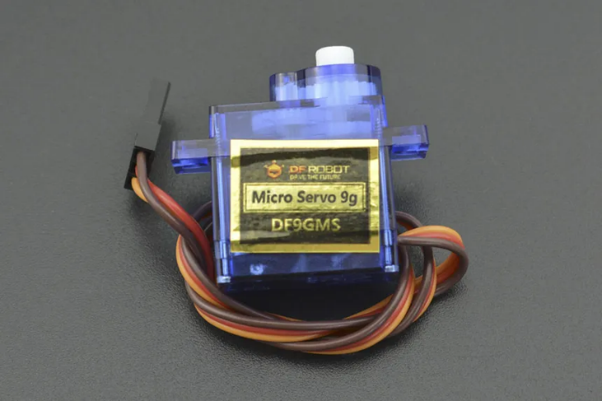

1. **Ultrasonic Distance Sensor Module HC-SR04:**

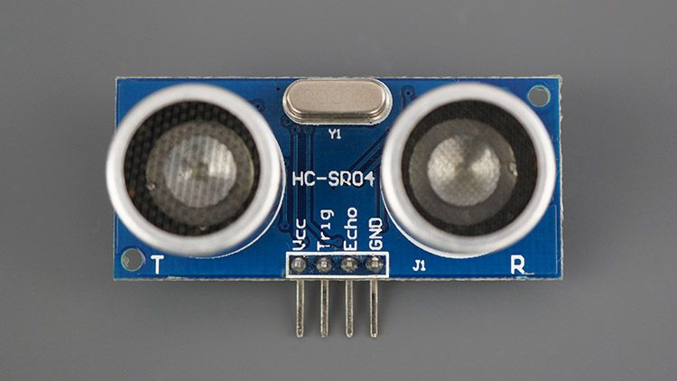

1. **Arduino Uno:**

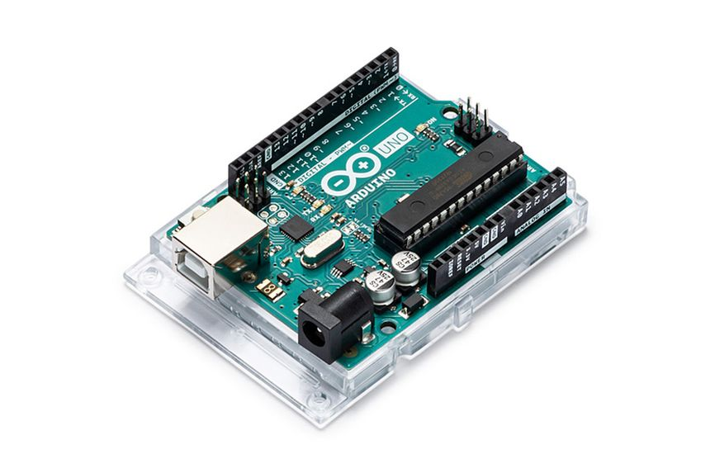

1. **Raspberry pi:** Used for management of the whole system. The image processing and capturing.
2. **Soil Moisture Sensor:** Used for capturing the live soil moisture levels that helps in automatic watering.
3. **Relay Module:** used in controlling the motor for watering.
4. **Rain Sensor Module:** Used to detect rain and send live alerts to the farmer.
5. **Servo Motor:** Used in moving the pathfinder rover and also the camera for panoramic shots to be taken of weed and diseases in plants.
6. **Ultrasonic Distance Sensor module:** To help the pathfinder rover to find its path.
7. **Arduino Uno:** Not included in the prototype presently but will be used for further expansion of the project for larger farms at a lower pricing.